1-10)Select a figure from amongst the
Answer Figures which will continue the same series as established by the five Problem Figures.

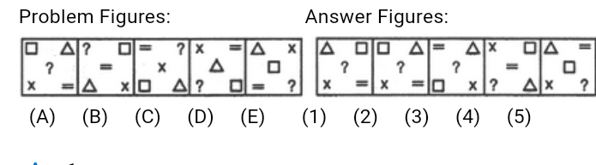

A.1 B.2 C.3 D.4 E.5
2.

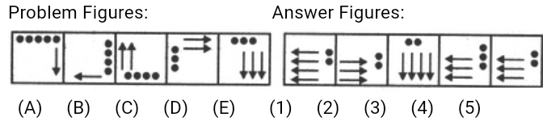
A.1 B.2 C.3 D.4 E.5
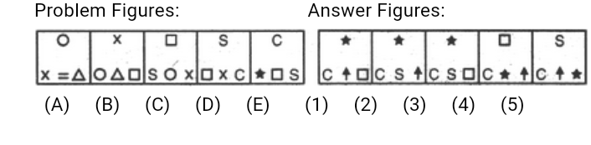
3.

A.1 B.2 C.3 D.4 E.5
4.
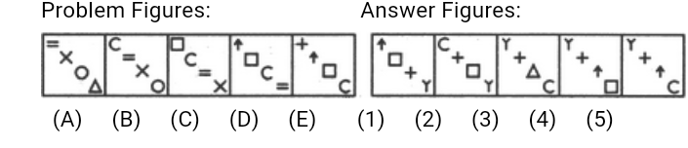

A.1 B.2 C.3 D.4 E.5
5.

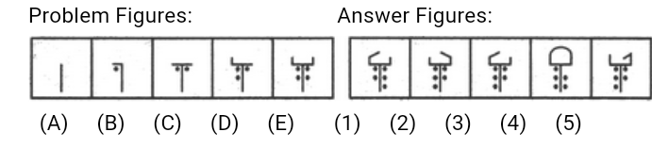
A.1 B.2 C.3 D.4 E.5
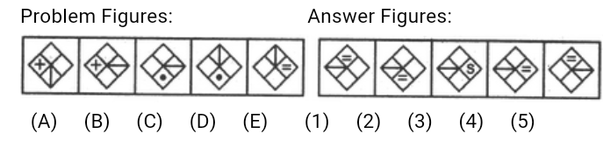
6.

A.1 B.2 C.3 D.4 E.5
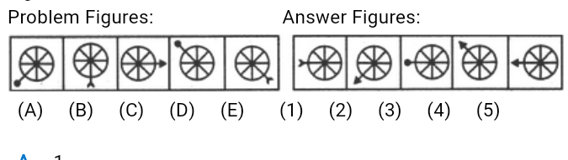
7.

A.1 B.2 C.3 D.4 E.5

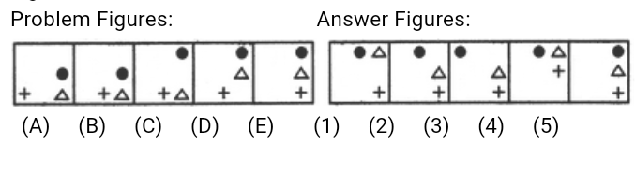
8.

A.1 B.2 C.3 D.4 E.5
9.
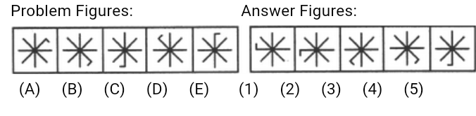

A.1 B.2 C.3 D.4 E.5

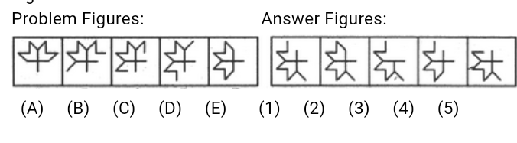
10.

A.1 B.2 C.3 D.4 E.5
11-20 )Find out the alternative figure which contains figure (X) as its part.
11.
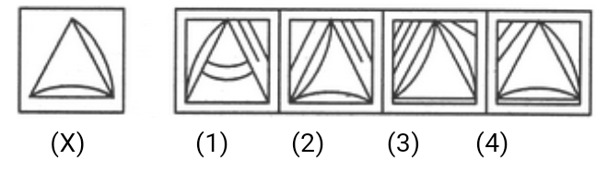

A.1 B.2 C.3 D.4

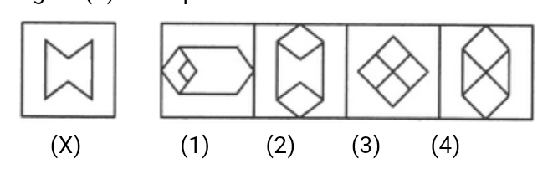
12

A.1 B.2 C.3 D.4
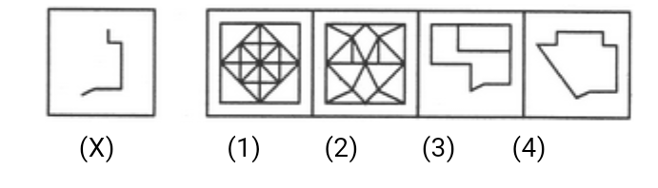
13.

A.1 B.2 C.3 D.4
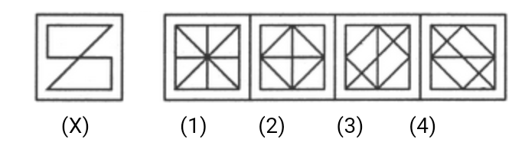
14

A.1 B.2 C.3 D.4
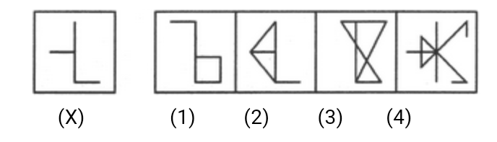
15.

A.1 B.2 C.3 D.4
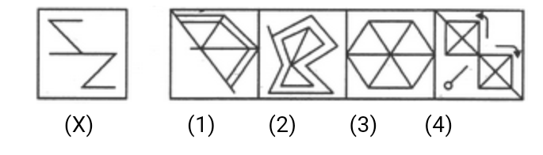
16.

A.1 B.2 C.3 D.4
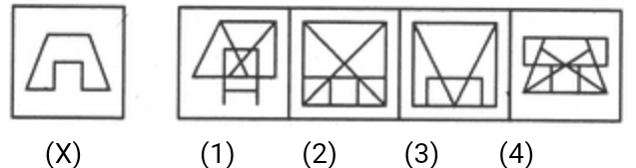
17.

A.1 B.2 C.3 D.4
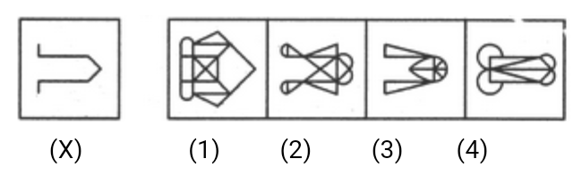
18.

A.1 B.2 C.3 D.4
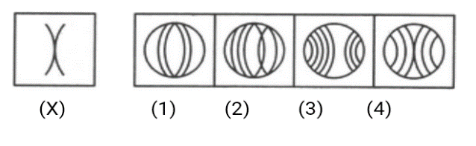
19.

A.1 B.2 C.3 D.4
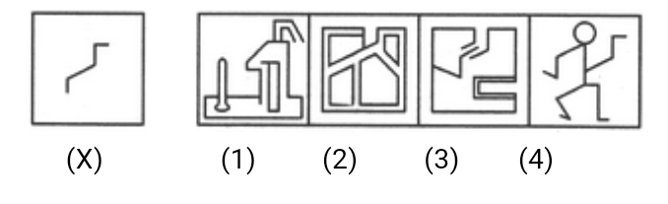
20.

A.1 B.2 C.3 D.4

